**Requirements Analysis Document**

Car Rental System - CRS

CSCI 4711 Software Engineering

Fall 2017

Augusta University

Augusta, GA

Date: 9/20/2017

Version 1

Team Members

James Rowland

Rebe LeGoullon

Adam Perry

Mitchell Williams

Jessie Siebeck

**Abstract**

This document contains the information regarding the design artifacts, requirements and analysis of the Car Rental System or CRS. The CRS is an application for Car rental services can deploy to electronically manage their customer rentals. This system is designed to assist employees in their day-to-day task.

The RentalAgent or Technician will be able to keep track of inventory and any damages that occur to the vehicles though their own respective controls. The RentalAgent will assist the customer in the pickup process by selecting a car from an available inventory list. From there the RentalAgent will be able to see any damage that has occurred, license plate, and other information regarding the car. They also will get customer information to store such as insurance, credit card, and license and contact information. The Technician will be able to see any previous damage listed as well and after assessing the car upon return report new damage. If any new damage occurs the Technician will be able to give an estimated cost of repair and submit the car back in the inventory.

This document describes the analysis, design artifacts and requirements of the Car Rental System and is structured as follows. Chapter 1 contains an introduction, a brief overview of the application. Chapter 2 outlines our functional requirements of the application and gives use case examples and descriptions. Chapter 3 shows intended mockups of the application to help demonstrate information in Chapter 2.

**Table of Contents**

|  |  |  |  |  |
| --- | --- | --- | --- | --- |
| 1 | INTRODUCTION……………………………………………............. | | | 4 |
|  | 1.1 | SCOPE OF SYSTEM………………………………………………… | 4 |  |
|  | 1.2 | OVERVIEW OF DOCUMENT……………………………………… | 5 |  |
| 2 | REQUIREMENTS OF SYSTEM……………………………………. | | | 6 |
|  | 2.1 | FUNCTIONAL REQUIREMENTS………………………………….. | 6 |  |
|  | 2.2 | USE CASES………………………………………………………….. | 7 |  |
|  | 2.3 | USE CASE DESCRIPTIONS………………………………………... | 8 |  |
| 3 | USER INTERFACE MOCKUPS……………………...….…………. | | | 21 |
|  | 3.1 | LOGIN………………………………………………………………... | 21 |  |
|  | 3.2 | LOGOUT………………………………………………………………... | 23 |  |
|  | 3.3 | PICKUP…………………………………….……….. | 24 |  |
|  | 3.4 | RETURN……...…………………………………… | 26 |  |

# Introduction

## Scope of System

Car Rental Systems is a distributed information system for vehicle inventory management, customer information storage, and car rental services. The actors associated with the system are as follows: the RentalAgent is responsible for car rental pickups and the collection of customer information, and the Technician handles the return process for car rentals, as well as assessing and applying additional charges due to vehicular damage incurred while in the customer’s care. The RentalAgent can view available cars in the inventory and rent the vehicle to a customer. The Technician can view a vehicle’s record and return the customer’s rental in the system.

The system supports both actors by maintaining an up to date list of available cars in the inventory, allowing the RentalAgent to process rental pickups and store customer information, as well as cancel rental requests before completion. The system is capable of accessing the customer information stored in a database and charging the customer the total rental cost using the customer’s stored payment information upon return of the rental. The RentalAgent and the Technician actors interact with the Car Rental System through separate interfaces, limiting their tasks based on their user type.

The system includes functionality for verifying users, managing vehicle information, as well as facilitating car rentals and returns and processing customer payments. Both the RentalAgent and Technician can log in and out of the system. Only the RentalAgent is capable of viewing the PickupRental interface and only the Technician can view the ReturnRental interface. All data stores are internal and part of the system. The system is stand-alone, and any external interaction is restricted to RentalAgent and Technician users only.

## overview of document

The rest of this document is structured as follows. Chapter 2 outlines the functional requirements of the system. Within this chapter is a list of functional requirements of the Car Rental System. It also includes a use case model of those functional requirements. A detailed description of each functional requirement then follows.

# requirements of system

## Functional Requirements

* Login – All users of the system must login to verify that they are an employee of Car Rental Systems as either a RentalAgent or a Technician. This function verifies the user and grants them access to other functionality.
* Logout – This allows users of the system to logout. This closes the connection to the system and prevents unauthorized use.
* PickupRental – This function allows a RentalAgent of Car Rental Systems to rent an available vehicle to a customer and record a customer’s contact and payment information. The RentalAgent is able to cancel a rental during this process.
* ReturnRental – This function allows Technicians to process rental returns and apply any additional costs due to vehicular damage incurred during the customer’s possession.

## use cases

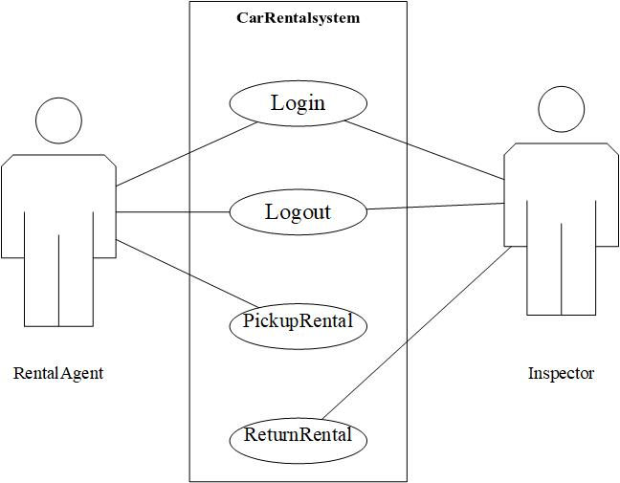

Figure 2.1 use case diagram for Car Rental System

## use case descriptions

|  |  |
| --- | --- |
| *Use case name* | Login |
| *Participating*  *Actors* | Initiated by RentalAgent and Technician |
| *Flow of events* | 1. “Login” functionality is activated when the user fills out the login form and pushes the submit button on the login form. The login form contains a field for a username and a field for a password. 2. **Software receives the form and verifies the username and username and password. The information is valid. The user is logged in, and is displayed their respective homepages.** |
| *Entry condition* | The submit button is pressed. |
| *Exit condition* | The user is logged in and displayed their homepage. |
| *Security*  *requirements* | 1. The password field should not display any text.  2. All SQL queries should be structured to prevent SQL injections. |

Figure 2.2 Login: Successful validation of Credentials

|  |  |
| --- | --- |
| *Use case name* | Login |
| *Participating*  *actors* | Initiated by RentalAgent and Technician |
| *Flow of events* | 1. “Login” functionality is activated when the user fills out the login form and pushes the submit button on the login form. The login form contains a field for a username and a field for a password. 2. **Software receives the form and verifies the username and username and password. The information is not valid. The following error message is displayed on the login form: “Invalid username and password”** |
| *Entry condition* | The submit button is pressed. |
| *Exit condition* | An error message is displayed on login form. |
| *Security*  *requirements* | 1. The password field should not display any text.  2. All SQL queries should be structured to prevent SQL injections. |

Figure 2.3: Login: Failed due to invalid credentials

|  |  |
| --- | --- |
| *Use case name* | Logout |
| *Participating*  *Actors* | Initiated by RentalAgent and Technician |
| *Flow of events* | 1. The logout button is pressed from the user’s homepage. 2. **The software displays a message asking the user if they are certain they wish to logout. A logout and a cancel button is presented with the message.** 3. The user presses the logout button. 4. **The user is logged out from the software and presented the login page.** |
| *Entry condition* | The logout button is pressed from the user’s homepage. |
| *Exit condition* | The user is logged out and presented the login page. |
| *Security*  *requirements* |  |

Figure 2.4 Logout: Confirmed

|  |  |
| --- | --- |
| *Use case name* | Logout |
| *Participating*  *actors* | RentalAgent and Technician |
| *Flow of events* | 1. The logout button is pressed from the user’s homepage. 2. **The software displays a message asking the user if they are certain they wish to logout. A logout and a cancel button is presented with the message.** 3. The user presses the cancel button. 4. **The user is presented back to their homepage.** |
| *Entry condition* | The logout button is pressed from the user’s homepage. |
| *Exit condition* | The user is presented back to their homepage. |
| *Security*  *requirements* |  |

Figure 2.5 Logout: Canceled

|  |  |
| --- | --- |
| *Use case name* | PickupRental |
| *Participating*  *actors* | Initiated by RentalAgent |
| *Flow of events* | 1. This function is activated when a user selects the “Rental” button on the RentalAgent homepage. 2. **System presents the Car Selection screen for the RentalAgent to select which available vehicle is to be rented.** 3. RentalAgent and customer go over available vehicles.Once selection is made, the RentalAgent uses the “Next” button on the Car Selection screen. 4. **The system presents an Approval Screen for the RentalAgent to approve the selected vehicle for rental.** 5. RentalAgent can view a description of vehicle to verify condition by selecting the “View Description” button. This brings up the Vehicle Description Screen. 6. **System presents the Vehicle Description Screen for RentalAgent to review and edit the vehicle description.** 7. RentalAgent approves current condition and saves the description by selecting the “Save Description” button. 8. **System presents Approval Screen for final vehicle approval.** 9. RentalAgent approves the vehicle for rental by selecting the “Approve” button. 10. **System presents the Customer Information screen for the RentalAgent to gather customer’s information.** 11. RentalAgent enters the customer’s information and credit card into correct fields, then finalizes rental by selecting the “Submit” button. 12. **System schedules rental and displays RentalAgent homepage.** |
| *Entry condition* | The “Rental” button is clicked. |
| *Exit condition* | Rental is scheduled.  The RentalAgent homepage is displayed. |
| *Security*  *requirements* |  |

Figure 2.6 PickupRental: Scheduled Rental

|  |  |
| --- | --- |
| *Use case name* | PickupRental |
| *Participating*  *actors* | Initiated by Rental Agent |
| *Flow of events* | 1. This function is activated when a user selects the “Rental” button on the Rental Agent homepage. 2. **System presents the Car Selection screen for the Rental Agent to select which available vehicle is to be rented.** 3. Customer cancels mid process while on Car Selection Screen. Rental Agent selects “Cancel” button. 4. **System presents Rental Agent homepage.** |
| *Entry condition* | The “Rental” button is clicked. |
| *Exit condition* | Rental is canceled.  The Rental Agent homepage is displayed. |
| *Security*  *requirements* |  |

Figure 2.7 Pickup Rental: Rental Canceled on Car Selection Screen

|  |  |
| --- | --- |
| *Use case name* | PickupRental |
| *Participating*  *actors* | Initiated by Rental Agent |
| *Flow of events* | 1. This function is activated when a user selects the “Rental” button on the Rental Agent homepage. 2. **System presents the Car Selection screen for the Rental Agent to select which available vehicle is to be rented.** 3. Rental Agent and customer go over available vehicles based on Make, Model, Year, and Price per Day. Once selection is made, the Rental Agent uses the “Next” button on the Car Selection screen. 4. **The system presents an Approval Screen for the Rental Agent to approve the selected vehicle for rental.** 5. Customer cancels mid process while on Approval Screen. Rental Agent selects the “Cancel” button. 6. **System presents Rental Agent homepage.** |
| *Entry condition* | The “Rental” button is clicked. |
| *Exit condition* | Rental is canceled.  The Rental Agent homepage is displayed. |
| *Security*  *requirements* |  |

Figure 2.8 Pickup Rental: Rental Canceled on Approval Screen

|  |  |
| --- | --- |
| *Use case name* | PickupRental |
| *Participating*  *actors* | Initiated by Rental Agent |
| *Flow of events* | 1. This function is activated when a user selects the “Rental” button on the Rental Agent homepage. 2. **System presents the Car Selection screen for the Rental Agent to select which available vehicle is to be rented.** 3. Rental Agent and customer go over available vehicles based on Make, Model, Year, and Price per Day. Once selection is made, the Rental Agent uses the “Next” button on the Car Selection screen. 4. **The system presents an Approval Screen for the Rental Agent to approve the selected vehicle for rental.** 5. Rental Agent approves the vehicle for rental by selecting the “Approve” button. 6. **System presents the Customer Information screen for the Rental Agent to confirm information and submit to finalize rental.** 7. Customer cancels mid process. Rental Agent selects the “Cancel” button. 8. **System presents Rental Agent homepage.** |
| *Entry condition* | The “Rental” button is clicked. |
| *Exit condition* | Rental is canceled.  The Rental Agent homepage is displayed. |
| *Security*  *requirements* |  |

Figure 2.9 Pickup Rental: Rental Canceled on Customer Information Screen

|  |  |
| --- | --- |
| *Use case name* | ReturnRental |
| *Participating*  *Actors* | Initiated by Technician |
| *Flow of Events* | 1. This function is activated when a Technician selects the Return Vehicle button on the Technician homepage. 2. **System presents a form with a field for a license plate number.** 3. User enters license plate number of a vehicle that is being returned and presses “Enter”. 4. **System presents vehicle information, including make, model, year, customer name, and due date.** 5. The user selects “Return Vehicle” to confirm return. 6. **System presents the Vehicle Description screen for the Technician to view the details of the car and is provided with the options to select Report or Approve.** 7. Technician compares the details in Vehicle Description to the incoming vehicle. No damage is present. 8. **The system marks the vehicle as returned and displays Technician homepage.** |
| *Entry condition* | The “Return Vehicle” button is clicked. |
| *Exit condition* | Return is approved.  The Technician homepage is displayed. |
| *Security*  *requirements* |  |

Figure 2.10: Approved with no Damages

|  |  |
| --- | --- |
| *Use case name* | ReturnRental |
| *Participating*  *Actors* | Initiated by Technician |
| *Flow of Events* | 1. This function is activated when a Technician selects the Return Vehicle button on the Technician homepage. 2. **System presents a form with a field for a license plate number.** 3. User enters license plate number of a vehicle that is being returned and presses “Enter”. 4. **System presents vehicle information, including make, model, year, customer name, and due date.** 5. The user selects “Return Vehicle” to confirm return. 6. **System presents the Vehicle Description screen for the Technician to view the details of the car and is provided with the options to select Report or Approve.** 7. Technician compares the details in Vehicle Description to the incoming vehicle. If new damage is found, the Technician selects Damage. 8. **System presents the Vehicle Damage screen where Technician can report the details of the damage.** 9. Technician enters a description of the vehicle damage and a value for the estimated cost of repair, and then selects Approve. 10. **System marks vehicle as damaged and returned and displays Technician homepage.** |
| *Entry condition* | The “Return Vehicle” button is clicked. |
| *Exit condition* | Return is approved.  The Technician homepage is displayed. |
| *Security*  *requirements* |  |

Figure 2.11 Return: Approved with Damages

|  |  |
| --- | --- |
| *Use case name* | ReturnRental |
| *Participating*  *Actors* | Initiated by Technician |
| *Flow of Events* | 1. This function is activated when a Technician selects the Return Vehicle button on the Technician homepage. 2. **System presents a form with a field for a license plate number.** 3. User presses “Cancel” on the form during interaction. 4. **System returns to the Technician homepage.** |
| *Entry condition* | The “Cancel” button is clicked on the license form. |
| *Exit condition* | The Technician homepage is displayed. |
| *Security*  *requirements* |  |

Figure 2.12 Return: License Form Cancelled

|  |  |
| --- | --- |
| *Use case name* | ReturnRental |
| *Participating*  *Actors* | Initiated by Technician |
| *Flow of Events* | 1. This function is activated when a Technician selects the Return Vehicle button on the Technician homepage. 2. **System presents a form with a field for a license plate number.** 3. User enters license plate number of a vehicle that is being returned and presses “Enter”. 4. **System presents vehicle information, including make, model, year, customer name, and due date.** 5. The user selects “Return Vehicle” to confirm return. 6. **System presents the Vehicle Description screen for the Technician to view the details of the car and is provided with the options to select Report or Approve.** 7. Technician compares the details in Vehicle Description to the incoming vehicle. If new damage is found, the Technician selects Damage. 8. **System presents the Vehicle Damage screen where Technician can report the details of the damage.** 9. Technician selects “Cancel”. 10. **System returns to previous page.** 11. Technician selects “Approve”. 12. **System marks vehicle as returned and displays Technician homepage.** |
| *Entry condition* | The “Return Vehicle” button is clicked. |
| *Exit condition* | Return is approved.  The Technician homepage is displayed. |
| *Security*  *requirements* |  |

Figure 2.13 Return: Approved with Damage Report Cancelled

|  |  |
| --- | --- |
| *Use case name* | ReturnRental |
| *Participating*  *Actors* | Initiated by Technician |
| *Flow of Events* | 1. This function is activated when a Technician selects the Return Vehicle button on the Technician homepage. 2. **System presents a form with a field for a license plate number.** 3. User enters license plate number of a vehicle that is being returned and presses “Enter”. 4. **System presents vehicle information, including make, model, year, customer name, and due date.** 5. The user selects “Return Vehicle” to confirm return. 6. **System presents the Vehicle Description screen for the Technician to view the details of the car and is provided with the options to select Report or Approve.** 7. The technician cancels the return by clicking “Cancel”. 8. **System presents the Technician homepage.** |
| *Entry condition* | The “Return Vehicle” button is clicked. |
| *Exit condition* | Return is approved.  The Technician homepage is displayed. |
| *Security*  *requirements* |  |

Figure 2.14 Return: Inspection Form Cancelled

# USER INTERFACE MOCKUPS

## Login

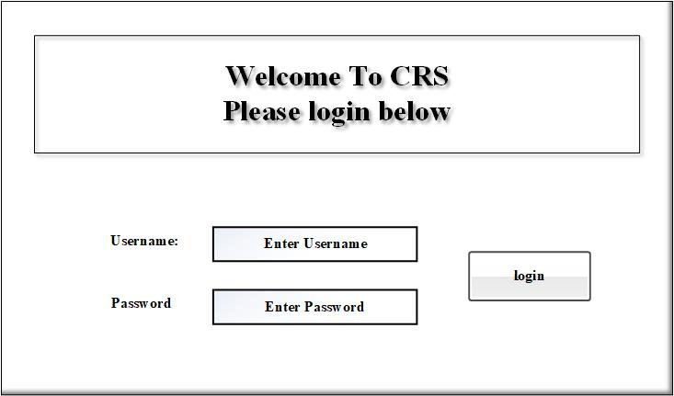

Figure 3.1: Login

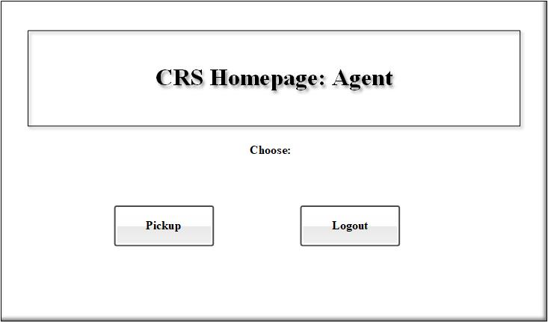

Figure 3.2: Login Agent Homepage

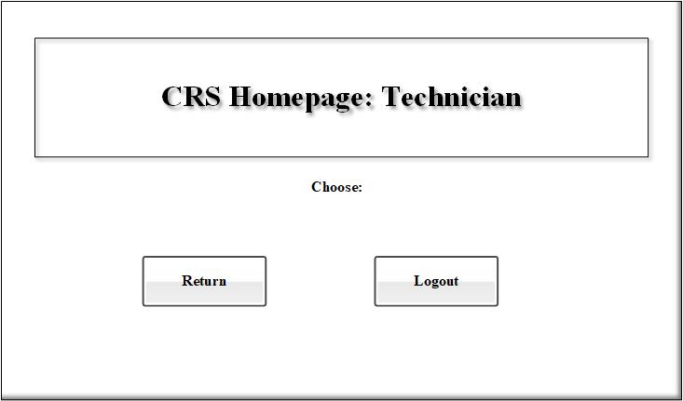

Figure 3.3 Login Tech Homepage

## Logout



Figure 3.4: Logout Agent Homepage



Figure 3.5 Logout Tech Homepage

## Pickup

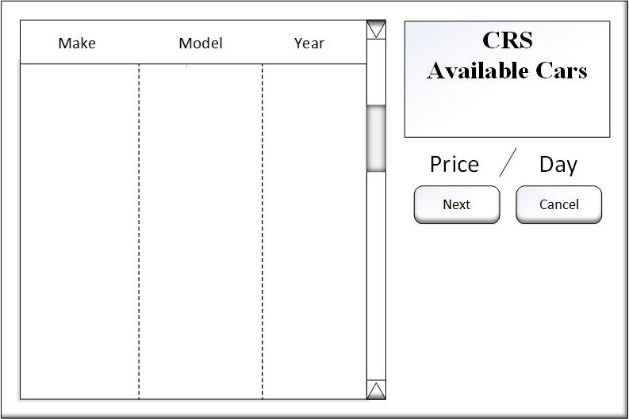

Figure 3.6 Pickup: Available inventory

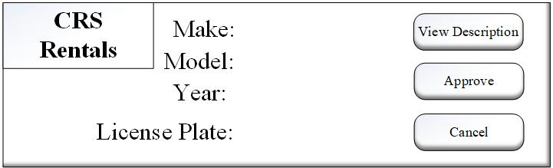

Figure 3.7 Pickup: Basic information

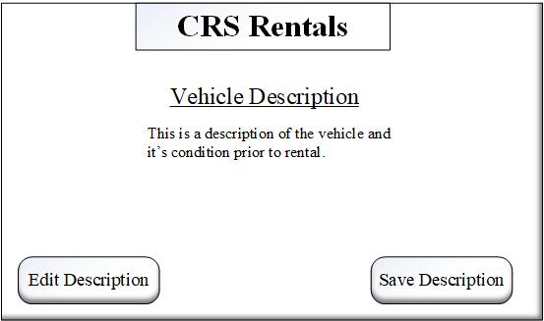

Figure 3.8 Pickup: Description of Condition

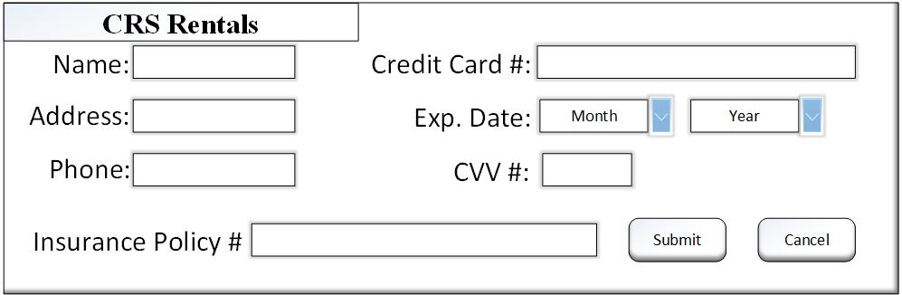

Figure 3.9 Pickup: Final conformation

## Return

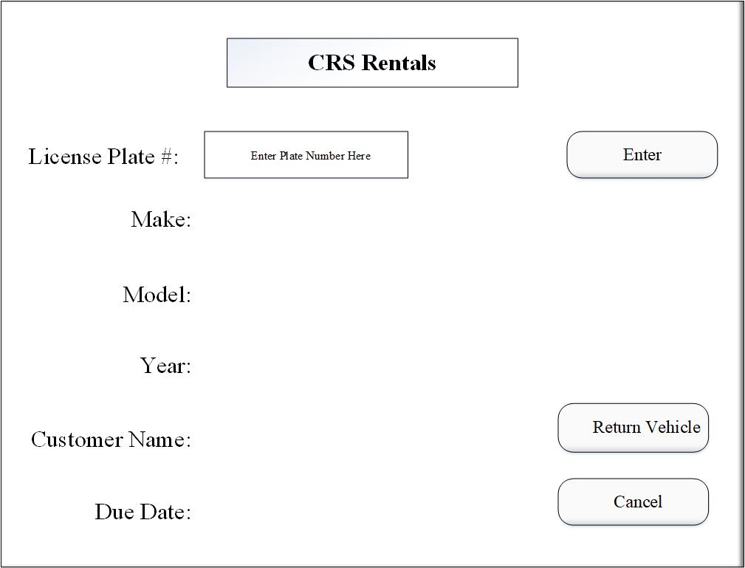

Figure 3.10 Return: Information Lookup

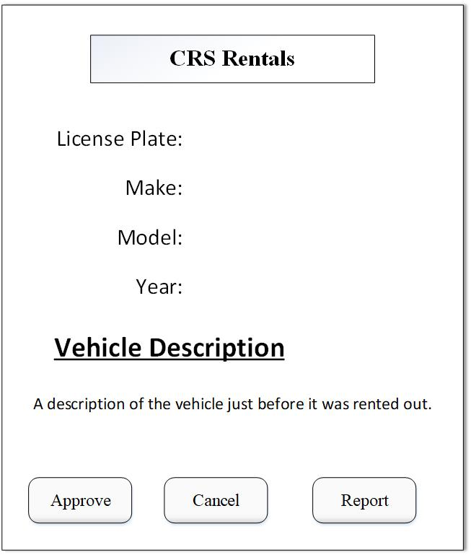

Figure 3.10 Return: Information on pickup condition

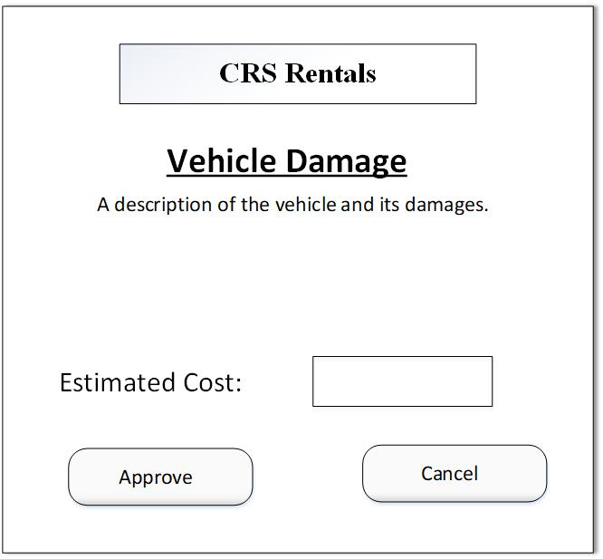

Figure 3.10 Return: Information update